**GROUP A** [23 Marks]

Q1. The network diagram for a software project is shown below, with three time estimates (optimistic, most likely, and pessimistic) for each activity. Activity times are in weeks.

[3+5+3+4]

|  |  |  |
| --- | --- | --- |
|  | B. 2-4-6 |  |
| A. 1-3-4 |  | C. 2-3-5 |
| D. 3-4-5 | E. 3-5-7 | F. 5-7-9 |

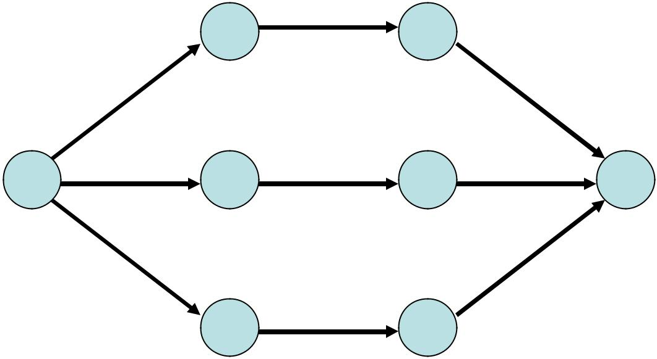

I. 3-4-6

G. 2-3-6

H. 4-6-8

**Answer the following:**

1. Develop the probabilistic project model and compute the Beta distribution expected duration, variance, and standard deviation for each task.

|  |  |  |  |  |  |
| --- | --- | --- | --- | --- | --- |
|  | **Beta Distribution** | | | | |
|  |  | **Duration** | | |  |
| **\*Task\*** | **μ** |  | **σ2** |  | **σ** |
| A | 2.8 |  | 0.3 |  | 0.5 |
| B | 4.0 |  | 0.4 |  | 0.7 |
| C | 3.2 |  | 0.3 |  | 0.5 |
| D | 4.0 |  | 0.1 |  | 0.3 |
| E | 5.0 |  | 0.4 |  | 0.7 |
| F | 7.0 |  | 0.4 |  | 0.7 |
| G | 3.3 |  | 0.4 |  | 0.7 |
| H | 6.0 |  | 0.4 |  | 0.7 |
| I | 4.2 |  | 0.3 |  | 0.5 |

1. Identify
   * How many paths are in the project?
   * The slack, expected duration, variance and standard deviation for each path.
   * The critical path.
   * The expected project duration.
   * Does the critical path have the largest variance? If not, which path has the highest variability?

|  |  |  |  |  |  |  |  |  |  |
| --- | --- | --- | --- | --- | --- | --- | --- | --- | --- |
| **Path** | **Time** | **Crit** | **Slack** | **σ2** | **σ** | **Tasks** | **Start** | **2** | **3** |
| **1** | **10.0** |  | **6.0** | **0.9** | **1.0** | **3** | **A** | **B** | **C** |
| **2** | **16.0** | **CP** | **0.0** | **1.0** | **1.0** | **3** | **D** | **E** | **F** |
| **3** | **13.5** |  | **2.5** | **1.1** | **1.1** | **3** | **G** | **H** | **I** |

1. Calculate each path probability for completing the project in 17 weeks. Show your answer to 4 decimal places of accuracy.

|  |  |  |  |
| --- | --- | --- | --- |
| **Start** | **2** | **3** | P (< 17**)** |
| **A** | **B** | **C** | **1.0000** |
| **D** | **E** | **F** | **.8413** |
| **G** | **H** | **I** | **.9995** |

1. Identify
   * The early and late start for each task.
   * The early and late finish for each task.
   * The slack for each task.
   * The critical tasks.

|  |  |  |  |  |  |  |
| --- | --- | --- | --- | --- | --- | --- |
|  | **Early** | | **Late** | | **Task** | **Crit** |
| **Task** | **Start** | **Finish** | **Start** | **Finish** | **Slack** | **Task** |
| **A** | **0.0** | **2.8** | **6.0** | **8.8** | **6.0** |  |
| **B** | **2.8** | **6.8** | **8.8** | **12.8** | **6.0** |  |
| **C** | **6.8** | **10.0** | 12.8 | **16.0** | **6.0** |  |
| **D** | **0.0** | **4.0** | **0.0** | **4.0** | **0.0** | **CT** |
| **E** | **4.0** | **9.0** | **4.0** | **9.0** | **0.0** | **CT** |
| **F** | **9.0** | **16.0** | **9.0** | **16.0** | **0.0** | **CT** |
| **G** | **0.0** | **3.3** | **2.5** | **5.8** | **2.5** |  |
| **H** | **3.3** | **9.3** | **5.8** | **11.8** | **2.5** |  |
| **I** | **9.3** | **13.5** | **11.8** | **16.0** | **2.5** |  |

.

Q2. The AON diagram is shown for a software project is shown below, with the most likely estimate for each activity. Activity times are in days. [2+4+1+1]

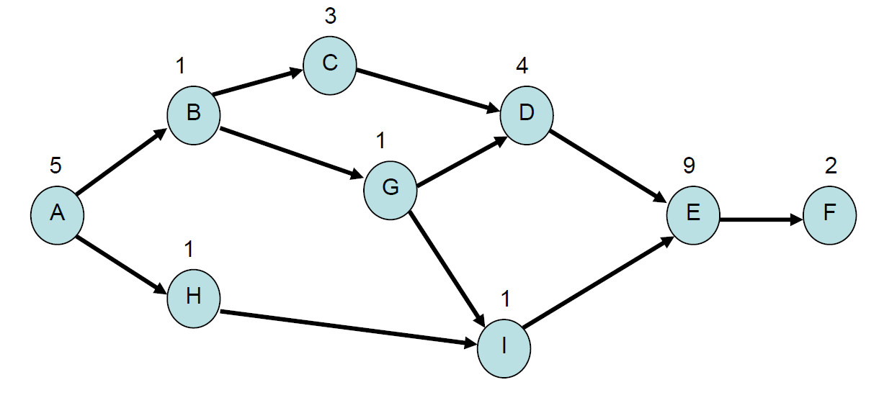

Answer the following:

a. Convert the AON diagram to an AOA diagram. Hint: The AOA diagram will require 2 dummy

activities which you should label D1 and D2.

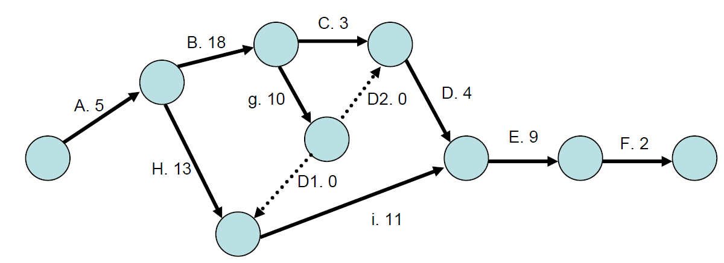

b. Use the AON diagram and identify all paths, the expected length of each path, the critical path,

most likely project duration, and slack time for each path.

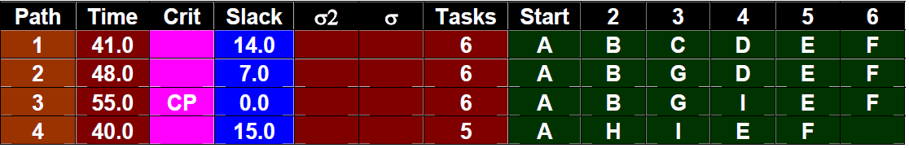

c. Which task has the largest slack time?

**H**

d. What is the latest start time for task E?

**Day 44**

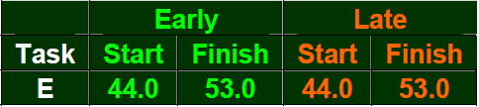

**GROUP B** [27]

Q3. NTT DATA has four potential projects all with an initial cost of $2,000,000. The capital budget for the year will only allow NTT DATA industries to accept one of the four projects. Given the discount rates and the future cash flows of each project, which project should they accept? What are the IRRs of the four projects for NTT DATA? [5+5]

|  |  |  |  |  |
| --- | --- | --- | --- | --- |
| ***Cash Flows*** | ***Project M*** | ***Project N*** | ***Project O*** | ***Project P*** |
| ***Year one*** | $500,000 | $600,000 | $1,000,000 | $300,000 |
| ***Year two*** | $500,000 | $600,000 | $800,000 | $500,000 |
| ***Year three*** | $500,000 | $600,000 | $600,000 | $700,000 |
| ***Year four*** | $500,000 | $600,000 | $400,000 | $900,000 |
| ***Year five*** | $500,000 | $600,000 | $200,000 | $1,100,000 |
| ***Discount Rate*** | 6% | 9% | 15% | 22% |

**Solution**, find the NPV of each project and compare the NPVs.

Project M’s NPV = -$2,000,000 + $500,000/1.05 + $500,000/1.052 + $500,000/1.053 + $500,000/1.054 + $500,000/1.055

Project M’s NPV = -$2,000,000 + $476,190.48 + $453,514.74 + $431,918.80 + $411,351.24 + $391,763.08

**Project M’s NPV = $164,738.34**

Project N’s NPV = -$2,000,000 + $600,000/1.09 + $600,000/1.092 + $600,000/1.093 + $600,000/1.094 + $600,000/1.095

Project N’s NPV = -$2,000,000 + $550,458.72 + $505,008.00 + $463,331.09 + $425,055.13 + $389,958.83

**Project N’s NPV = $333,790.77**

Project O’s NPV = -$2,000,000 + $1,000,000/1.15 + $800,000/1.152 + $600,000/1.153 + $400,000/1.154 + $200,000/1.155

Project O’s NPV = -$2,000,000 + $869,565.22 + $604,914.93 + $394,509.74 + $228,701.30 + $99,435.34

**Project O’s NPV = $197,126.53**

Project P’s NPV = -$2,000,000 + $300,000/1.22 + $500,000/1.222 + $700,000/1.223 + $900,000/1.224 + $1,100,000/1.225

Project P’s NPV = -$2,000,000 + $245,901.64 + $335,931.20 + $385,494.82 + $406,259.18 + $406,999.18

**Project P’s NPV =-$219,413.98 (would reject project regardless of budget)**

And the ranking order based on NPVs is,

Project N – NPV of $333,790.77

Project O – NPV of $197,126.53

Project M – NPV of $164,738.34

Project P – NPV of -$219,413.98

**NTT DATA should pick Project N.**

**Solution,** this is an iterative process but can be solved quickly on a calculator or spreadsheet.

Enter the keys noted for each project in the CF of a Texas BA II Plus calculator

|  |  |  |  |  |
| --- | --- | --- | --- | --- |
| ***Cash Flows*** | ***Project M*** | ***Project N*** | ***Project O*** | ***Project P*** |
| ***CFO*** | -$2,000,000 | -$2,000,000 | -$2,000,000 | -$2,000,000 |
| ***CO1, F1*** | $500,000, 1 | $600,000, 1 | $1,000,000, 1 | $300,000, 1 |
| ***CO2, F2*** | $500,000, 1 | $600,000, 1 | $800,000, 1 | $500,000, 1 |
| ***Year three*** | $500,000, 1 | $600,000, 1 | $600,000, 1 | $700,000, 1 |
| ***Year four*** | $500,000, 1 | $600,000, 1 | $400,000, 1 | $900,000, 1 |
| ***Year five*** | $500,000, 1 | $600,000, 1 | $200,000, 1 | $1,100,000, 1 |
| ***CPT IRR*** | 7.93% | 15.24% | 20.27% | 17.72% |

Q4. Tom is the CTO of an international reputed company. His company provides digital innovation, software engineering and management consulting services.

Comparing All Methods that we learned (NPV, Payback Period, Profitability Index) -- Tom is looking at a project with the estimated cash flows as follows:

Initial Investment at start of project: $3,600,000

Cash Flow at end of Year 1: $500,000

Cash Flow at end of Years 2 through 6: $625,000 each year

Cash Flow at end of Year 7 through 9: $530,000 each year

Cash Flow at end of Year 10: $385,000

Top management of this company wants to know the Payback Period, NPV, and Profitability Index of this project. The appropriate discount rate for the project is 14%. If the cut-off period is six years for major projects, determine if the project is accepted or rejected under the three different decision models. [3+3+3]

**Solution:**

Payback Period = -$3,600,000 + $500,000 + $625,000 + $625,000 + $625,000 + $625,000 + $625,000 = $ 25,000 and we only need part of year 6 so,

$600,000 / $625,000 = **0.96 and Payback Period is 5.96 years and project is accepted.**

NPV = -$3,600,000 + $500,000 / 1.14 + $625,000/1.142 + $625,000/1.143 + $625,000/1.144 + $625,000/1.145 + $625,000/1.146 + $530,000/1.147

+ $530,000 /1.148 + $530,000/1.149 + $385,000/1.1410

NPV = -$3,600,000 + $438,596.49 + $480,917.21 + $421,857.20 + $370,050.17

+ $324,605.42 + $284,741.59 + $211,807.78 + $185,796.30 + $162,979.21

+ $103,851.37 = **-$614,797.27 and project is rejected using NPV rules.**

Present Value of Benefits = $500,000 / 1.14 + $625,000/1.142 + $625,000/1.143 + $625,000/1.144 + $625,000/1.145 + $625,000/1.146 + $530,000/1.147

+ $530,000 /1.148 + $530,000/1.149 + $385,000/1.1410

Present Value of Benefits = $438,596.49 + $480,917.21 + $421,857.20 + $370,050.17 + $324,605.42 + $284,741.59 + $211,807.78 + $185,796.30 + $162,979.21+ $103,851.37 = $2,985,202.73

Present Value of Costs: $3,600,000

**Profitability Index = $2,985,202.73 / $3,600,000 = 0.8292 and reject.**

Q5. The following table gives data on normal time and cost and crash time & cost for a project

|  |  |  |  |  |
| --- | --- | --- | --- | --- |
| Activity | Normal | | Crash | |
| Time(weeks) | Cost (Taka) | Time(weeks) | Cost (Taka) |
| 1-2 | 3 | 300 | 2 | 400 |
| 2-3 | 3 | 30 | 3 | 30 |
| 2-4 | 7 | 420 | 5 | 580 |
| 2-5 | 9 | 720 | 7 | 810 |
| 3-5 | 5 | 250 | 4 | 300 |
| 4-5 | 0 | 0 | 0 | 0 |
| 5-6 | 6 | 320 | 4 | 410 |
| 6-7 | 4 | 400 | 3 | 470 |
| 6-8 | 13 | 780 | 10 | 900 |
| 7-8 | 10 | 1000 | 9 | 1200 |
| **Total cost = Taka 4220** | | | | |

The indirect cost per week is **Taka 50**.

a. Draw the network for the project & Critical path.

b. Find optimum time and optimum cost.

c. Determine minimum total time & corresponding cost.

[2+3+3]

Solution:

1. 1-2-5-6-7-8 = 32 weeks it is critical path (CPM) of the project duration.
2. optimum cost (Taka 5805) and optimum duration (29 weeks)
3. minimum total time (25 weeks) & corresponding cost (Taka 6150)

<http://docplayer.net/15560128-B-2-4-6-d-3-4-5-e-3-5-7-f-5-7-9.html>

Solution:

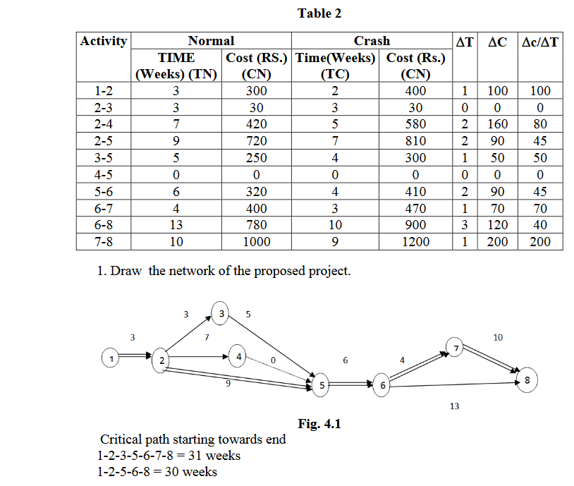

1-2-5-6-7-8 = 32 weeks it is critical path (CPM) of the project duration.

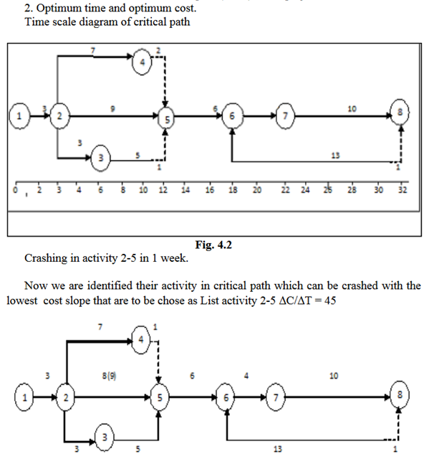

**Fig. 4.3**

Crashing in activity 5-6 in 2 weeks

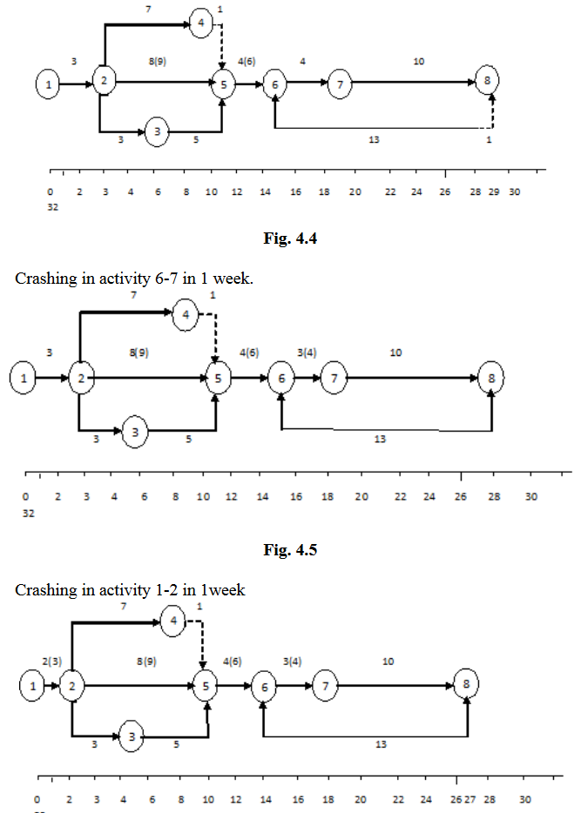

**Fig. 4.6**

Crashing in activity 6-8 in 2 week



